Project da Vinci

Modeling Financial Markets Through Spectral Methods, Convection, and Diffusion

A Lightning Custom Shop Project

# Introduction

Financial market behavior is largely considered a mystery. Behaviors seem largely uncorrelated to the underlying mechanics of what should be driving the behavior in the market. An attempt has been made via the Black-Scholes equation, which is describes the behavior of Options ($V\left(t,s\right)$) relative to Stock Price ($S$).

Equation . The Black-Scholes Equation.

$$\left\{\begin{aligned}\frac{∂V}{∂t}+\frac{1}{2}σ^{2}S^{2}\frac{∂^{2}V}{{∂S}^{2}}+rS\frac{∂V}{∂S}-rV=0 \\ V\left(T,s\right)=K\left(s\right) ∀s\end{aligned}\right.$$

Note that $t$ is simply time, $r$ is the risk-free interest rate, and $σ$ is the volatility of the stock.

Now, those who are familiar with the general convection-diffusion equation will note that the diffusion term either has the wrong sign or there are imaginary values in the volatility or stock price. On the other hand, this may mean that the equation inherently has no ability to diffuse behaviors and is inherently unstable.

Equation . Generalized Convection-Diffusion Equation. $ϕ$ is a scalar that can convect & diffuse, $Γ$ is the diffusion value, $F$ is the net of the forcing functions, and $ε$ is the error of the stochastic behavior.

$$\frac{Dϕ}{Dt}=∇∙\left(Γ∇ϕ\right)+F+ε$$

# Methods

## Transport of Price

All this leads to the question of, what are our dimensions? For the scope of this paper, only the stock price will be considered, and no aspects of options, fundamentals, or otherwise. Thus, we know that $ϕ$ is going to be stock price velocity, and $t$ will obviously be time. This leaves the decision of what will the space dimension represent. Arguably, the best representation is the number of sales. This is helpful as the convective velocity then become the trade volume. Thus, the left-hand side of the Convection-Diffusion Equation becomes:

Equation . The Left-Hand Side Convection. $S$ is the stock price, $U$ is the trade volume, and $X$ is the sales.

$$\frac{∂\dot{S}}{∂t}+U\frac{∂\dot{S}}{∂X}$$

Now, the stock price velocity is simply defined as the time derivative of the stock price. Just using the stock price

# Data

## S&P 500 Comparison

The S&P 500 provides a standard set of data to compare against that is, at least in theory, a measure of the whole of the stock market. The data, as seen in Figure 1, is a long-term set of data that is as far as yFinance can provide.

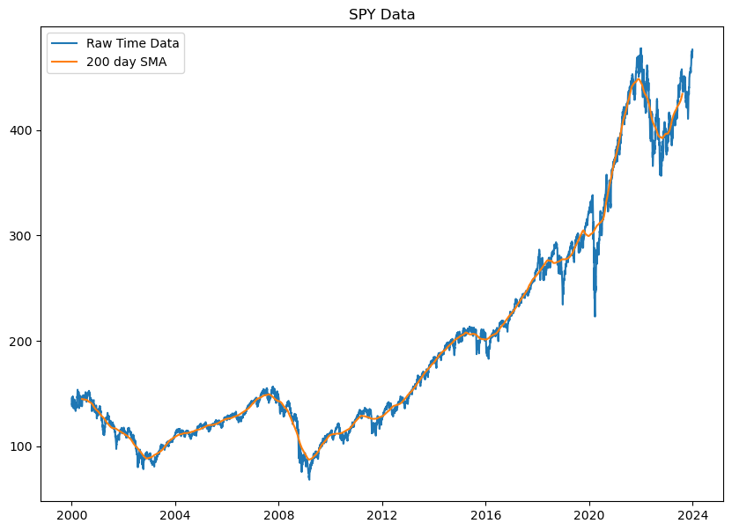

Figure .

The correlations for this data, shown in Figure 2, are interesting in understanding overall trends, but provides minimal insight into specific behavior of the S&P 500, or at least in the domain of time. What it does reveal is that prices are relatively highly correlated over the course of the long-term. There is an observable 90% correlation between prices at ~500 days, 80% correlation between ~1,000 days, and there is a trend of a fluctuation away from the decrease in correlation at ~2,000 days. This last remark indicates that there is some ~8 year change in the trend.

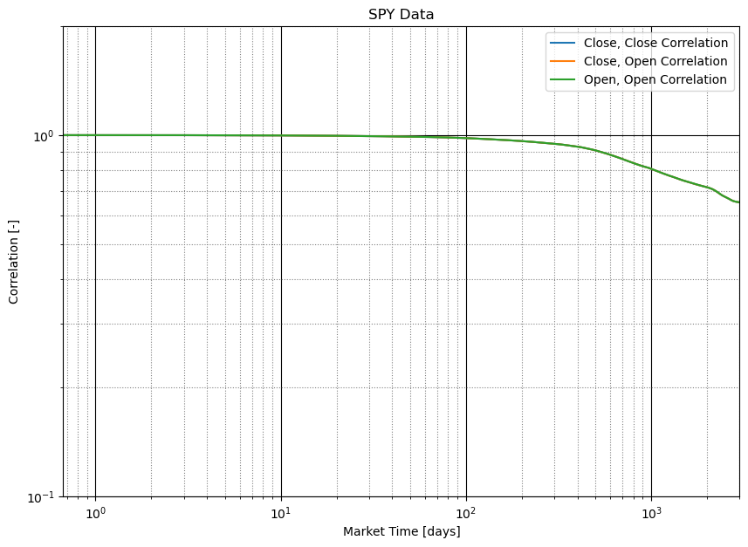

Figure .

This data on its own may not be particularly, helpful, but one can take the energy spectra and draw better conclusions from it. This energy spectra is normalized to the area under the curve to help remove any other senses of scale. The trend of any dissipation in this energy spectra then in turn reflects the order of the fractal that is present in the data. With a fit from SciPy’s curve_fit method, this is ~2.02, meaning that the fractal exists in just over 2 dimensions in the full-term of the S&P 500 data. This is an interesting comparison, as even turbulent boundary layers begin as single, or close to, dimensional dissipation, and require deeper transport phenomena to reach higher dimensions.

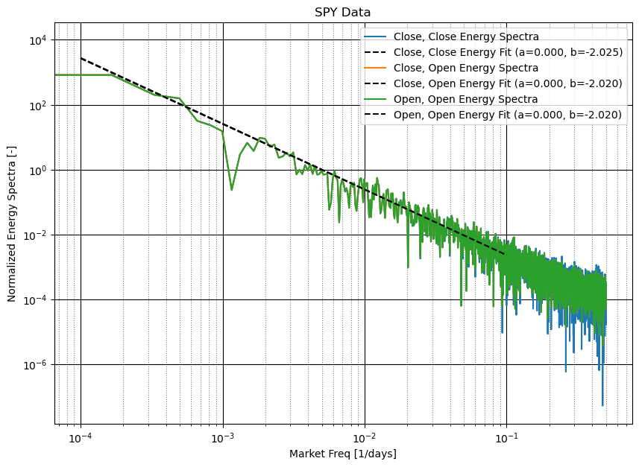

Figure .